**Amar Gajanan Mohite**

Section – IFT562

**Arizona State University**

Instructor**:** Daniel Wells

**Activity 3 -** **Troubleshoot Create Instance**

Date – 21/01/2024

* Activity 3: The output of the cat create-lamp-instance-userdata.txt command from Task 3.1.  Add your full name to the command line before taking the screenshot.

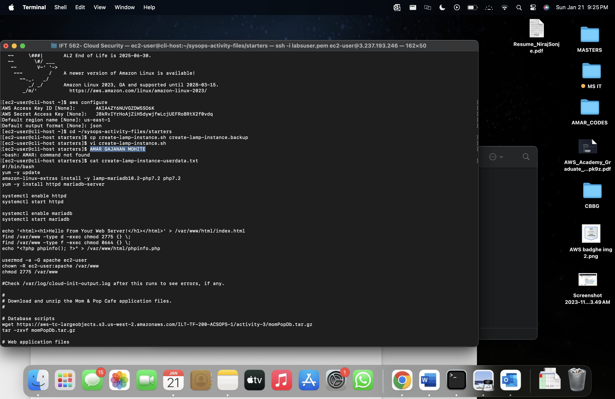

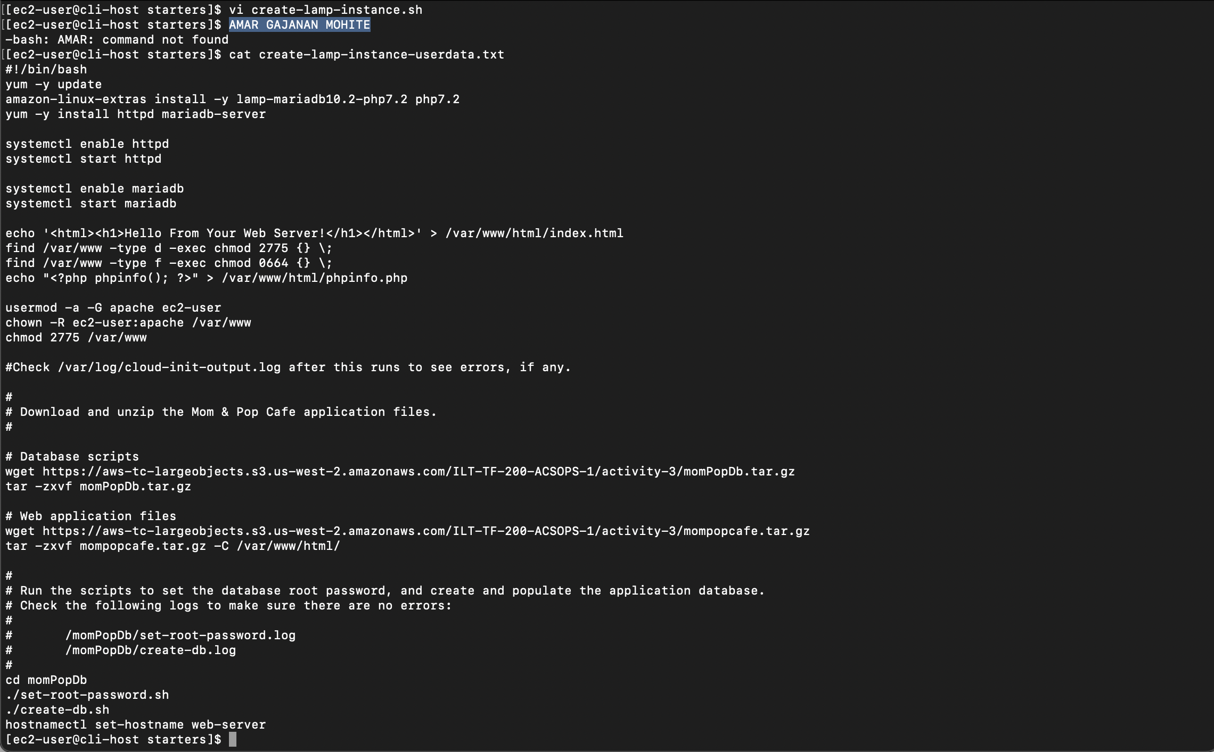

Activity2: The output of the tail command on the cloud-init-output.log.  Stop the tail and add your full name to the command line before taking the screenshot.

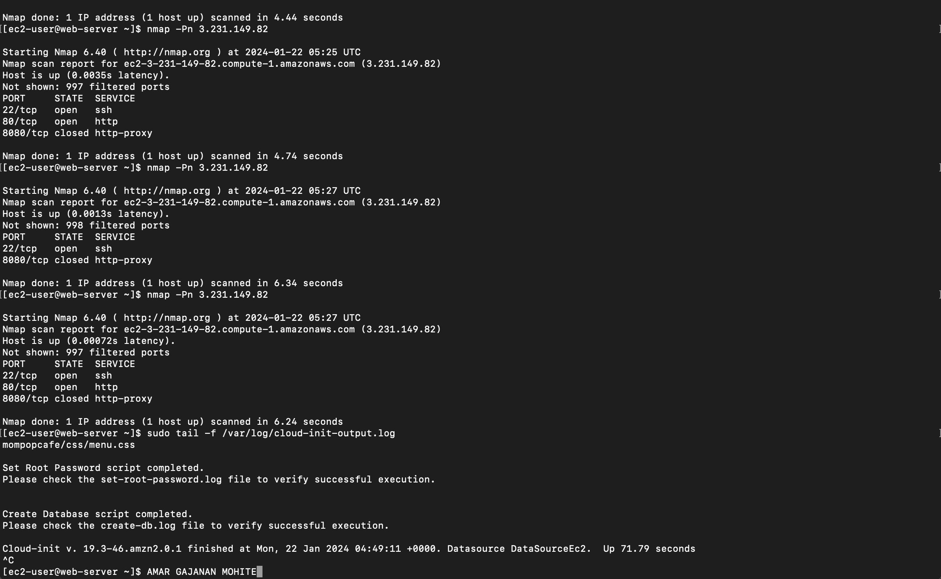

Activity3:A screenshot of the order history page showing at least 1 order.  Add your full name to the address bar of your web browser.

